31. Develop a system using UML for Agriculture Loan Management System. The admin should add new customers and view his/her records. The admin should check the defaulters. The customer can see his/her account detail and apply for a new loan by providing the required documents. The admin should verify the document submitted and approve the loan after verifying the payback potential of the customer.

**USECASE:**

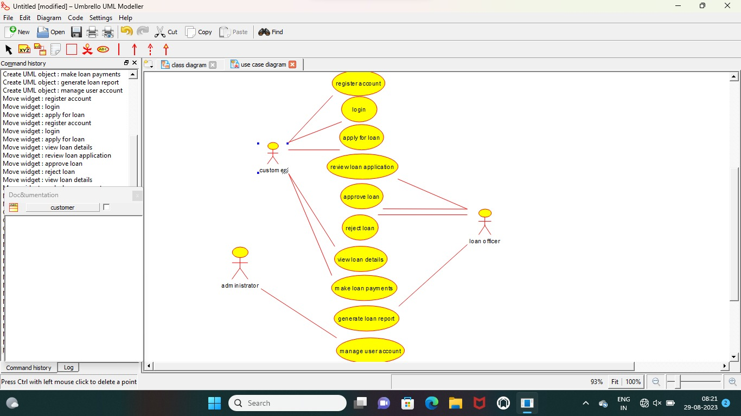

**ACTIVITY :**

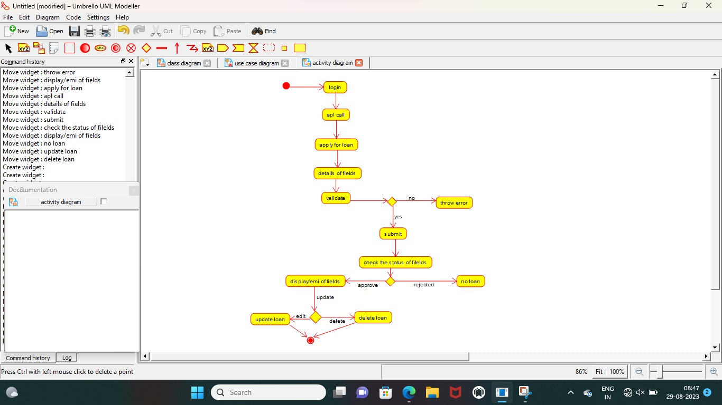

**CLASS :**

